Launching Italian Restaurant in Pune

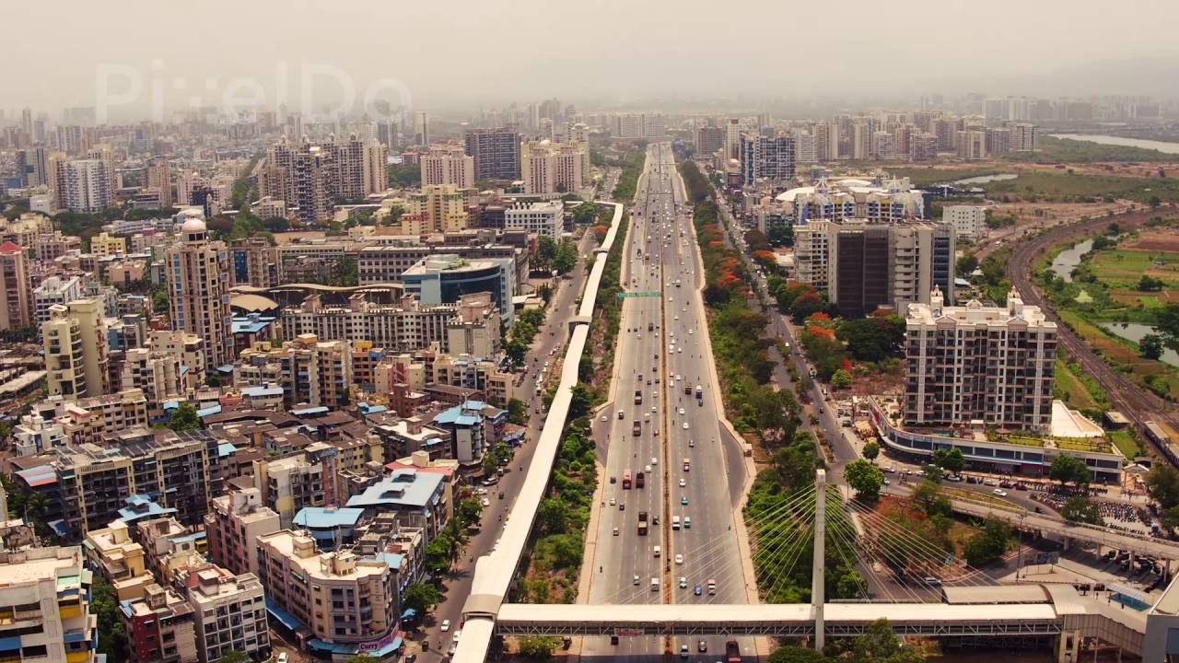

In this project I will provide information about Pune City in India and then after I will provide information about specific areas [Kothrud, Baner and Hinjewadi] in Pune where someone can open an Italian restaurant.

I have chosen these three areas where Italian restaurant can be opened. Analysis will be provided about these three areas with visualization graphs so that decision can be easy for the person opening restaurant in these areas.

I have lived in many cities over the years. However, PUNE holds a special place in my heart. No other place has given the level of thrill, fun, memories, holidays & opportunities as Pune. The city emerged drastically over the span of last 10 years and was awarded as the 2nd best city to live in India.

The top reasons why Pune is the best city to live in India.

Booming IT Sector Everyone knows that India produces the largest number of Software Experts in the world & IT Industry has become the backbone of the economy. With over 110 MNCs, Pune is home to some of the biggest and stunning IT parks of India. There are more than 5 official IT zones in Pune with Rajiv Gandhi Infotech Park in Hinjewadi being the biggest of all. This IT park is spread over an area of 13 KMs with the presence of all major companies like TCS, Infosys, Wipro, Persistent, Cognizant, Accenture, etc. Such large landscape of companies gives great exposure to Job seekers in the Silicon Valley of India.

Educational Hub This is the sole thing Pune was famous for in the old days. Pune is known as the educational hub of India since years. There are world famous Universities and Colleges for each academic zone.

Pune University has an affiliation with 57 Engineering colleges which itself is a record. There are top management schools like Symbiosis. Pune has earned the reputation of “Oxford of the East.” Being a top spot for Educational Institutes, it has also become a favorite place for Summits, Global Events, Concerts & Fests.

Food & Shopping These things are core elements of one’s decision to open Restaurant in a city. Well, luckily you can get both at very reasonable price and with lots of variety in Pune. There are plenty of mega shopping malls in like Pheonix Market City, Amanora Town, Seasons Mall, Inorbit & Pune Central. As the city have plenty of young crowds, one can find many street shopping places on MG Road, Laxmi Road, FC Road, etc.

When it comes to Food, one can get all the variety of different lip-smacking cuisine in the city. From traditional street food to 7 courses dine at a five-star restaurant, you will get every option to try.

Everyone knows that you get to eat tasty Vadapav in Maharashtra. However, Puneri Misal beats it in all possible manner. There are more than 5000 restaurants in the city. You can get food even at 3 AM if you’re planning to pull an all-nighter.

Comfortable Lifestyle Although Pune is next big city in Maharashtra after Mumbai, it is still pretty much cheaper when it comes to lifestyle. **Property rates are too much lower in comparison to Mumbai**, and this really helps the budget for opening Restaurant in a city.

**Data Description**

I used **Forsquare API** to get the most common venues of Areas of Pune.

Specifically, I have chosen Kothrud, Baner and Hinjewadi

### Methodology

### I used python folium library to visualize geographic details of Pune and I used latitude and longitude values to get the visual as below:

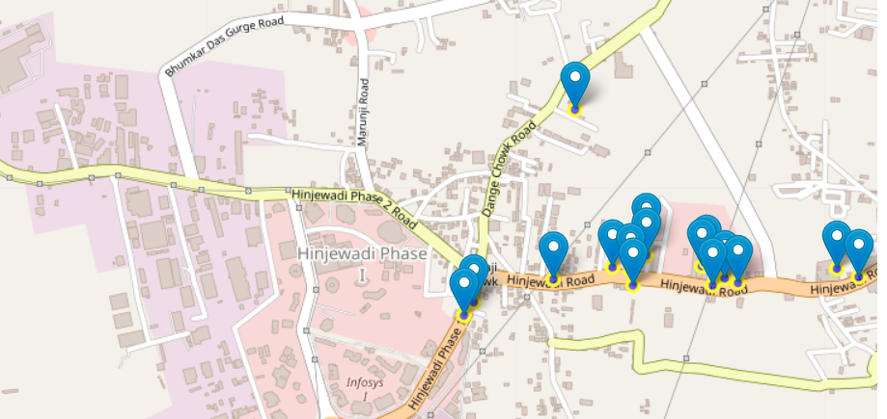

I utilized the Foursquare API to explore

I designed the limit as **100 venues** and the radius **2000 meters** for each area from their given latitude and longitude information.

LIMIT = 100 # limit of number of venues returned by Foursquare API

radius = 2000 # define radius

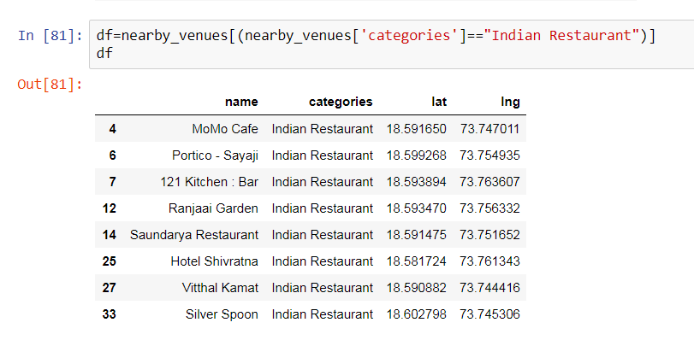

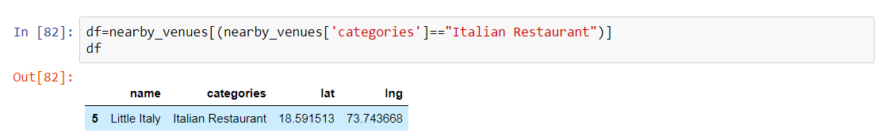

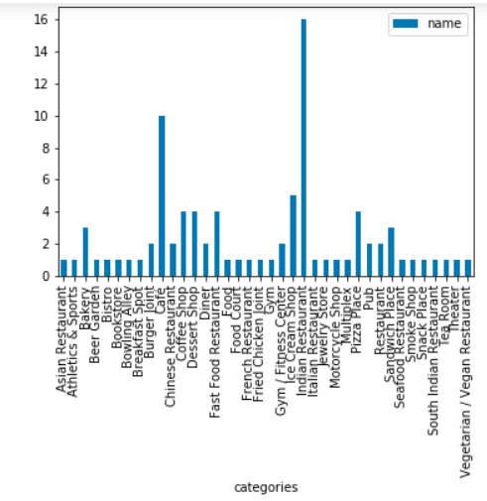

Here is a head of the list Venues name, category, latitude and longitude informations from Forsquare API.

we just run single Latitude and Longitude pair for each area.

We have some common venue categories in Areas. In this reason I used unsupervised learning K-means algorithm to cluster the Areas. K-Means algorithm is one of the most common cluster method of unsupervised learning.

I will also provide real estate information about areas and real estate data will be used for comparisons of appropriate location for the area.

A heat map is data analysis software that uses color the way a bar graph uses height and width. I will use heat map to show real estate data and also show categories in the heat map.

